Project Planning and Management
By Masud Rana Mushfiq

Chapter 1: Introduction to Project Management

Definition of a Project: A project is formally defined as a temporary endeavor undertaken to create a unique product, service, or result.

Project Characteristics
Projects have two primary attributes that distinguish them from ongoing business operations:
- Unique Outcome: Every project brings about a product, service, or process that has not existed before in that specific context. Even constructing a replica of an existing building is considered a project because it requires unique planning, team management, and tailoring to a specific location and environment.
- Temporary Nature: Unlike operations, which are ongoing and repetitive, projects have a definite beginning and end date. A project is complete once its goals are achieved, or when it is determined the project is no longer viable (e.g., funding is exhausted, the strategy changes, or legal regulations end the project).

Some reasons to terminate the projects earlier than their scheduled completion time can be listed as follows:
- Funding is exhausted or no longer available,
- Resources (human or physical resources, or services) are no longer available,
- The external client (funder) or the current or potential customers no longer wants the project completed
- The organization changed its strategy or determined a new priority
- Management decided to end the project, and
- A legal cause or a new regulation necessitated the project to end.

Project Success vs. Project Management Success
- Project Management Success: This focuses on the process—specifically, completing the project within the defined scope, on time (schedule), within budget (cost), and meeting quality standards.
- Project Success: This focuses on the impact of the final product or service on stakeholders. A project might be a management success (on time and on budget) but fail if it does not meet customer expectations or realize the expected business value.

Project Constraints
Projects are limited by six primary, competing constraints often referred to as the "Iron Triangle" or "Triple Constraints" and their extensions:
- Scope: The work required to deliver a result with specific features and functions; it is the foundation upon which the project is built.
- Schedule: A model for executing activities, representing how and when products and results will be delivered.
- Cost: The approved budget, including all expenses necessary for delivery.
- Quality: The standards and criteria the deliverables must meet to perform effectively.
- Resources: The human team members, physical equipment, materials, and services required to complete activities.
- Risk: Uncertain events that can have positive (opportunities) or negative (threats) effects on project objectives.

Project scheduling provides a detailed plan that represents how and when the project will carry out all the activities that would lead to the delivery of the products, services, and results defined in the project scope.

Two main factors determine the severity of a risk: (1) Probability of the occurrence, and (2) impact on the project.

Projects may fail due to the factors listed below:
- Unrealistic and vague goals
- Uncontrolled expansion of the project scope
- Absent or ineffective relations with the clients and other stakeholders
- Cost overruns
- Schedule delays
- The insufficient amount or quality of resources
- Toxic organizational culture and
- Organizational or team conflicts
- Poor communication with stakeholders
- Unsatisfied stakeholders
- Ineffective quality assurance and inspections, and or poor quality

Project Life Cycle and Process Groups

Project life cycle
The project life cycle is the sequence of phases a project goes through—from developing the project’s foundations, planning all knowledge areas, executing activities and producing outcomes, to reaching close-out by archiving documents, completing administrative work, and disbanding the team.
This cycle makes the project temporary and unique.

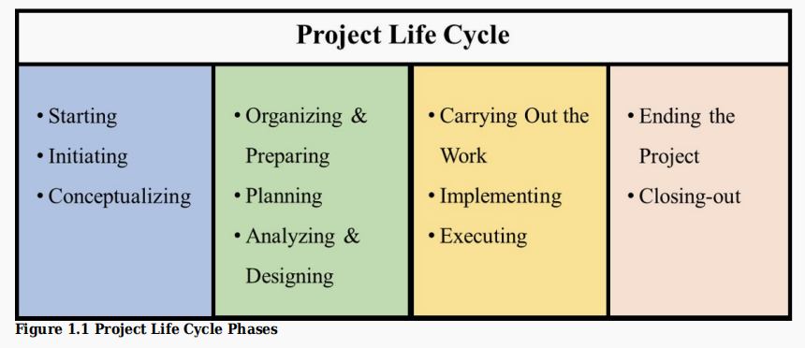

Process Groups:
Different from project life cycle phases, but in line with them, these processes are grouped inside five project management process. Names of these groups and their purposes are provided below:

Initiating: Obtaining authorization to start.
Planning: Defining the scope and course of action to attain objectives.
Executing: Completing the work defined in the plan.
Monitoring and Controlling: Tracking, reviewing, and regulating progress and initiating changes when needed.
Closing: Formally completing the project or phase.
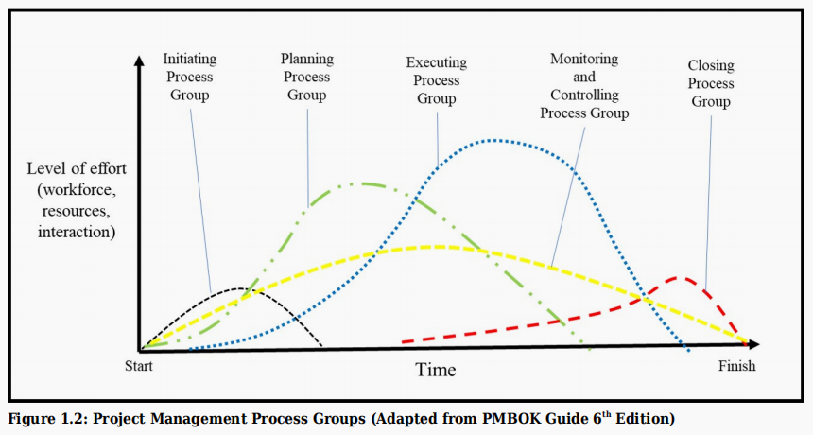
Chapter 02: Project Selection

SMART Objectives (Page 43)
To ensure success, project objectives must follow the SMART protocol, which serves as a set of performance metrics:

- Specific: Clear and unambiguous; answers "What do we want to accomplish?".
- Measurable: Uses quantitative criteria (numbers, percentages) to track progress and verify completion.
- Achievable: Realistic goals considering available resources, knowledge, and time.
- Relevant: Aligned with higher-level goals like the organization's strategic plan and mission.
- Time-based: Includes specific deadlines for when results must be met.

Business cases and projects are defined by objectives specifying expected end-results

The Business Case (Page 47)
A business case is a feasibility document created in the "Pre-Project" stage to justify a project based on economic, financial, or social impact.

The main components of a business generally consist of:
- Need statement (Underlying problems or opportunities)
  - The cause-effect diagram (fishbone diagram) is a useful instrument in this stage to identify the underlying issues rather than describing the surface-level issues.
- Statement of goals (Business requirements)
- Stakeholders and their requirements
- Analysis of current state and future state, and creation of a business change strategy
- Constraints, dependencies, assumptions, risks, critical success factors, and decision criteria
- Designs and alternative solutions
- Potential value (benefits and costs)

Project Selection Process (Page 50)
Organizations use financial and non-financial models to choose which projects to pursue due to limited resources.
- Financial Models:
  - Payback Period: The time required to recover the initial investment cost.
  - Net Present Value (NPV): A method that accounts for the Time Value of Money using a Discount Factor (which considers inflation and the required rate of return) to determine long-term profitability.
- Non-Financial Models:
  - Weighted Scoring Model: A tool that introduces objectivity by rating projects against prioritized criteria (e.g., strategic opportunity, IT advantage, market share). Each criterion is given a "weight" based on its importance, and projects are scored to find the best match.
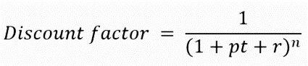
- NPV Score Decision Table: Often used within a weighted scoring model to assign points (e.g., 1 for unfavorable, 3 for favorable) based on the calculated NPV value

A weighted scoring model is a decision-making method used to evaluate and compare multiple options (such as projects) based on several criteria.
In this model:
- Each criterion (e.g., cost, risk, profitability) is assigned a weight according to its importance.
- Each option is given a score for every criterion.
- The scores are multiplied by their respective weights and then summed to get a total score.

The option with the highest total score is considered the best choice.
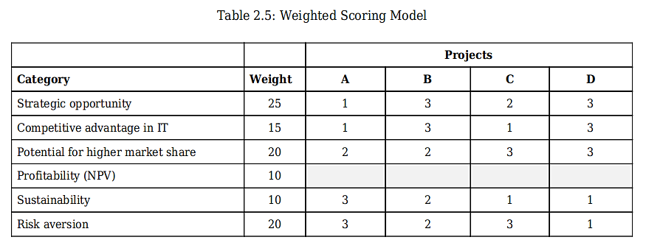

Chapter 03: Project Initiation

The Project Charter
The project charter is the document that formally authorizes the existence of a project and provides the project manager with the authority to apply organizational resources to project activities.
- Purpose: It signals the transition from the pre-project (business case) phase into the planning phase.
- Contents: A comprehensive charter typically includes the project purpose, measurable objectives, high-level requirements, a milestone schedule, a preapproved budget, a stakeholder list, and project exit criteria.

A project charter is a necessary document to initiate a project.

Project Charter Component:
- 1. Project purpose
- 2. Measurable project objectives
- 3. High-level requirements
- 4. High-level project description, boundaries, and key deliverables
- 5. Assumptions and constraints
- 6. Overall project risk
- 7. Summary milestone schedule
- 8. Preapproved financial resources
- 9. Key stakeholder list
- 10. Project approval requirements
- 11. Project exit criteria
- 12. Project team
- 13. Name and authority of the sponsor authorizing the project charter.

Project Exit Criteria
These are the conditions that describe when a project should be closed successfully or cancelled.
- Success: Closure occurs when deliverables pass final testing (e.g., beta testing for an app) and all resources are paid.
- Cancellation: A project may be terminated early if the organization’s strategy changes, funding is exhausted, or the project is no longer viable.

Project Environment
Projects are influenced by both internal and external factors, often referred to as Enterprise Environmental Factors (EEFs).

Internal Environment: Includes organizational culture, structure, geographic locations, resource availability, and employee capability.

External Environment: Consists of market conditions, social cultural influences, legal restrictions, and financial considerations.

Macro Forces : Broad external factors including Sociocultural, Technological, Economic, Government or Political, and Natural Disasters.

Industry Competition (Porter’s Five Forces): A tool to analyze micro-environmental factors: industry rivalry, threat of new entrants, threat of substitutes, supplier power, and buyer power.

The Porter’s Five Forces Model is a framework developed by Michael Porter to analyze the competitive forces in an industry and determine its profitability.
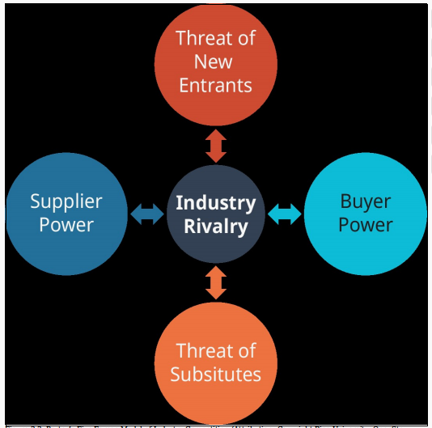

Organizational Dimensions and Structure
Organizations have formal and informal systems that dictate how projects are managed.

- Formal Subsystems: Govern tasks, reporting relationships, and the deployment of resources through authority, responsibility, and accountability.

- Organization Types:
  - Functional: The project manager has little to no authority; functional managers control the budget.
  - Matrix (Weak, Balanced, Strong): A blend where power is shared. In a Strong Matrix, the project manager has moderate to high authority and often works within a PMO.
  - Project-Oriented: The project manager has almost total authority and a full-time team.

- Informal Subsystems (Organizational Culture): The shared beliefs and values of an organization. The Competing Values Framework (Figure 3.10) identifies four culture types: Clan, Adhocracy, Hierarchy, and Market.

Project Management Office (PMO)
A PMO is an organizational structure that standardizes project governance and facilitates the sharing of resources and tools.
- Supportive PMOs: Provide templates and training (consultative role).
- Controlling PMOs: Require compliance with specific frameworks.
- Directive PMOs: Directly manage the projects

Chapter 4: Project Planning and the Project Scope

Project Planning and Constraints
Planning consists of the processes required to establish the project scope, refine objectives, and define the course of action to attain them.

Elicitation is not just collecting information. It means:
- discovering requirements
- gathering information from stakeholders
- understanding needs through discussion, research, observation, or experimentation

A requirement is:
- A usable representation of a need
- A condition or capability that must exist in a product, service, or result to satisfy a business or contractual need
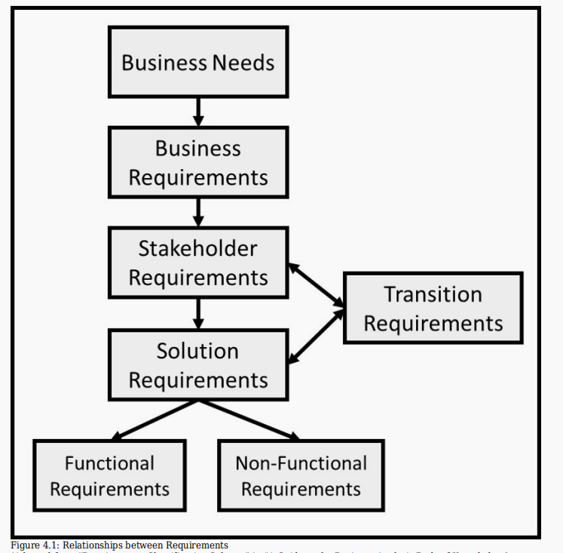

Project Scope Management
Scope planning defines all the work needed to successfully meet project objectives.
- Defining the Scope: This process generates a Project Scope Statement, which provides a detailed description of scope components, major deliverables, assumptions, and constraints.
- Deliverables: These are the tangible outcomes or measurable results produced for the client.
- Project Exclusions: Defining what is not included in the project is critical for managing expectations (e.g., excluding tablet support in a mobile-commerce project).

Work Breakdown Structure (WBS) is a hierarchical decomposition of a project into smaller, manageable parts that help in planning, scheduling, estimating, and controlling the work.

Definition
A WBS is a tree-like structure that breaks a project into:
- Phases
- Deliverables
- Sub-deliverables
- Work packages (smallest unit of work)
It starts from the main project goal and keeps dividing it into smaller components until the work becomes easy to estimate and manage.

0 Mobile Banking App Project
1 Project Initiation
1.1 Feasibility Study
1.2 Requirement Gathering
1.3 Project Charter Approval

2 System Design
2.1 UI/UX Design
2.1.1 Wireframe Design
2.1.2 Prototype Design
2.2 Database Design
2.3 Architecture Design

3 Development
3.1 Frontend Development
3.1.1 Login Module
3.1.2 Dashboard Module
3.1.3 Transfer Money Module
3.2 Backend Development
3.2.1 API Development
3.2.2 Security Implementation

4 Testing
4.1 Unit Testing
4.2 Integration Testing
4.3 System Testing
4.4 User Acceptance Testing

5 Deployment
5.1 App Store Submission
5.2 Server Deployment
5.3 Go Live

6 Maintenance
6.1 Bug Fixing
6.2 Updates & Enhancements
6.3 User Support

Full Lifecycle Coverage (Case Study 4.1 – Real WBS)
This WBS covers:
- Initiation (Scope)
- Analysis (Analysis/App Requirements)
- Design
- Development
- Testing
- Deployment
- Closure (Post Implementation Review)
Chapter 5: Stakeholder Management
A project starts with two processes – developing the project charter and identifying stakeholders.

Stakeholder (Page 123)
Stakeholders are individuals, groups, or organizations that can affect or be affected by a project's activities, decisions, or outcomes.

They are categorized into two main groups:
- Internal Stakeholders: These are inside the organization. Examples include the project sponsor, project manager, team members, the Project Management Office (PMO), functional managers, and employees of various departments (e.g., HR, Finance, IT), National Office.
- External Stakeholders: These are outside the organization. Examples include customers, end users, suppliers, contractors, shareholders, regulatory bodies, and government agencies.

Stakeholder Matrix: Power/Interest Grid (Page 126)
This tool is one of the most common techniques utilized to group stakeholders according to their level of authority (power) and their level of concern about the project’s activities and outcomes (interest).
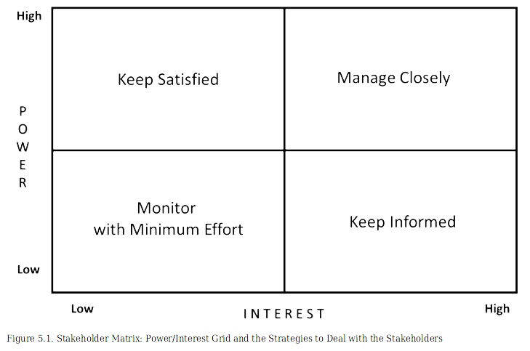
Properties of each quadrant with the potential stakeholder inside them have been described below:

1. High power – High interest: These stakeholders are decision-makers and have the biggest impact on the project’s success and hence we must closely manage their expectations. We should work closely with them to ensure that they agree with and support the change. The project sponsor, project manager, and the team can be included in this quadrant.

2. High power – Low Interest: These stakeholders need to be kept satisfied even though they aren’t interested because they yield power. This type of stakeholders should be dealt with cautiously as well since they may use their power in a not desired way in the project if they become unsatisfied. Government and regulatory agencies which inspect the quality of your work in compliance with legal provisions and standards can be included in this quadrant.

3. Low power – High interest: We should keep these stakeholders adequately informed and talk to them to ensure that no major issues are arising. They are likely to be very concerned and may feel anxious about a lack of control. They can often be very helpful with the detail of your project. Our customers or end-users who are willing to purchase the outcome of the project
(e.g., a product or a service) can be included in this quadrant.

4. Low power – Low interest: We should monitor these stakeholders, but do not bore them with excessive communication. The public and the customers who are not willing to purchase our products can be included in this quadrant. We can send them newsletters once every month, but not every week. We should monitor their interest and power level in case they may change.

Stakeholder Register
The stakeholder register is a living document used to track interests, involvement, and impact. It typically includes:
- Identification Info: Name, title, and contact details.
- Assessment: Power/Interest levels and risk ratings.
- Support Levels: Current vs. desired level of support (levels include: Supports Actively, Supports, Neutral, Opposes, or Opposes Actively).
- Engagement Strategy: Specific tactics to win over resistant stakeholders or maintain support.

Stakeholder Engagement Assessment Matrix
This tool evaluates engagement in five categories: Unaware, Resistant, Neutral, Supportive, and Leading. The matrix tracks the Current (C) level of engagement versus the Desired (D) level required for project success.

Responsibility Assignment Matrix: RACI Chart (Page 141)
The RACI chart is used to ensure clear roles for project work packages. It stands for:
- Responsible: The person who performs the work.
- Accountable: The person with final authority over the task's completion (only one person per task).
- Consult: Subject matter experts who provide input.
- Inform: People who need to be kept updated on progress but do not perform the work.
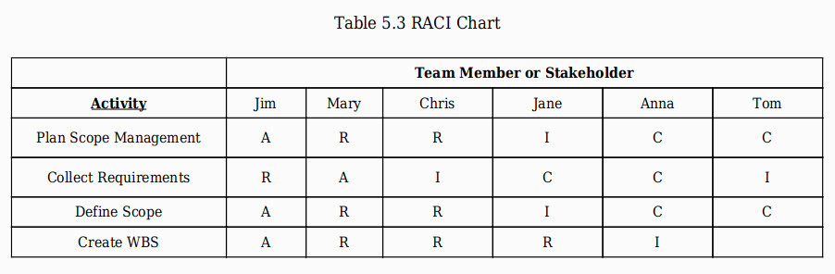

Level of support (either current or desired) can be evaluated in five levels:
- Supports Actively: Anticipates and feels the need for change, actively works with the project team.
- Supports: Anticipates and feels the need for change, but does not involve in the project team.
- Neutral: Neither supporting nor opposing.
- Opposes: Neither feels the need for change nor tries to prevent the change.
- Opposes Actively: Doesn’t see the need for change, actively working to prevent the change.

Chapter 6: Communication Management, Leadership, and Project Team Management

Communications Management in project management refers to the processes required to ensure effective and timely communication among all project stakeholders and team members.
It focuses on collecting, distributing, storing, and managing project information so that everyone is well-informed and aligned throughout the project lifecycle.

Communication Management Plan
Project managers spend approximately 90% of their time communicating. The Communication Management Plan is a formal document that guides how information is collected, distributed, and stored.
- Requirements Analysis: The plan must determine what information stakeholders need to make good decisions without overwhelming them.
- Protocols: It defines who is responsible for communicating, who authorizes the release of confidential data, the frequency of reports (daily, weekly, etc.), and the specific technologies used (e.g., Microsoft Teams, Zoom).

Communication Types
- Synchronous Communications: Occur when all parties participate at the same time. Examples include in-person meetings, phone calls, video conferences, and instant messaging (IM).
- Asynchronous Communications: Do not require parties to be present simultaneously. Examples include emails, faxes, and physical mail. This is useful for teams spread across different time zones.

Types of Skills for Project Managers
Project managers need three main skill sets:
a) Technical Project Management Skills
- Ability to apply project management methods and tools
- Planning scope, schedule, cost, risk, etc.
- Managing project execution and closure
- Choosing development approach (Agile or Waterfall)

b) Strategic and Business Management Skills
- Understanding business and industry knowledge
- Aligning project with organizational goals
- Knowledge of finance, marketing, operations (domain knowledge)

c) Leadership Skills
- Ability to guide and motivate team
- Includes communication, negotiation, problem-solving, and critical thinking
- Focus on achieving team goals and collaboration

Leadership and Interpersonal Skills
Project managers require a balance of technical project management, leadership, and strategic/business management skills.
- Listening: Active listening is critical; it involves understanding the speaker’s point of view and paying attention to body language and environmental cues.
- Negotiation: A process for developing a mutually acceptable outcome when desired results conflict.

The four principles of negotiation are:
  - Separate people from the problem.
  - Focus on common interests.
  - Generate options for shared interests.
  - Develop results based on standard criteria (project success).
- Trust and Emotional Intelligence (EQ): Building trust is foundational to complex projects. EQ involves self-awareness, self-regulation, empathy, and relationship management.

- Conflict Management: Thomas-Kilmann (TKI) Model
Conflict is assessed based on two dimensions: Assertiveness (satisfying one's own concerns) and Cooperativeness (satisfying others' concerns). The five modes are:
- Competing (Forcing): Assertive and uncooperative; power-oriented.
- Collaborating: Assertive and cooperative; seeking a "Win-Win" solution.
- Compromising: Intermediate; finding an expedient, mutually acceptable solution.
- Avoiding: Unassertive and uncooperative; sidestepping the issue.
- Accommodating: Unassertive and cooperative; involves self-sacrifice.

Leadership Styles
The book lists several styles, including:
- Laissez-faire: Hands-off approach.
- Transactional: Focuses on goals and feedback for rewards.
- Transformational: Empowers followers through innovation and idealized attributes.
- Servant Leadership: The favored style for agile projects; the leader serves the team by promoting self-awareness, listening, coaching, and removing obstacles.
- Charismatic: Leaders are able to inspire with high energy. They are enthusiastic and selfconfident and hold strong convictions.

Project Culture
Project managers create a culture through shared norms and values. This is enforced through symbols, storytelling, rituals, rewards/punishments, and taboos. A critical element is aligning official rules (stated policies) with operational rules (enforced behaviors).

We should answer the following questions in the communications management plan:
- What communication methods should we use to transfer information?
- How often should information or updates be shared with stakeholders? What is the reporting frequency for each stakeholder based on their needs?
- Who is responsible for communicating the information? Who approves the release of confidential information? Who receives the information based on their needs and expectations?
- Do we need new communication tools or systems, or can we use existing ones?
- Do team members and stakeholders have experience using these communication technologies, or do they need training?
- How is the project team structured? Are they co-located or spread across different locations?
- What resources, time, and budget are available for communication activities?

2. Leadership Role in Projects
Project managers:
- Work with people, not just tools and numbers
- Must understand behavior and motivation
- Act like an orchestra conductor, coordinating different team members to achieve one goal

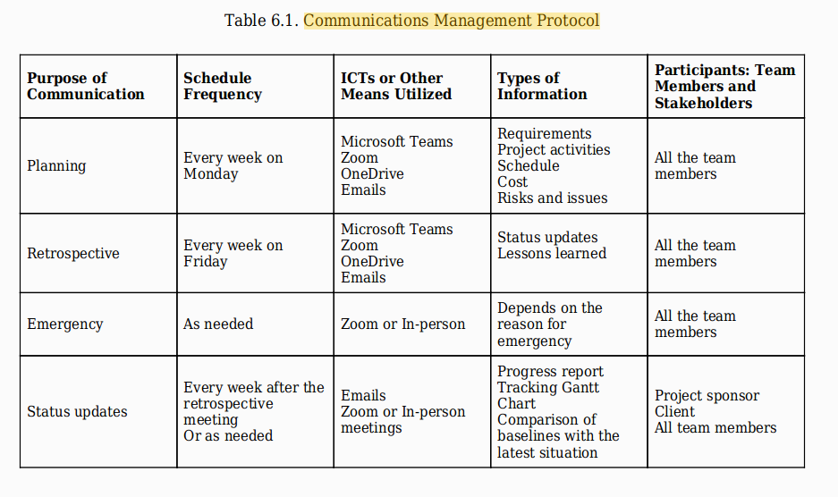

Chapter 7: Schedule Management

A project manager is responsible for planning, developing, managing, monitoring, and controlling the project schedule to ensure that project objectives can be achieved, and project outcomes can be delivered to the client and customers on time.

Project Schedule Management Plan (Pages 182-184)

This plan provides the guidelines on how to develop, manage, and control the project schedule. It consist of the following:

1. Unit of Measurement
Defines the time units used for scheduling project activities.
Example: 1 working day = 8 hours.

2. Activity List and Attributes
Lists all project activities with details like duration and resources.
Example: “Design UI – 5 days – assigned to designer.”

3. Level of Accuracy
Defines the acceptable range of error in time estimates.
Example: Activity estimated with ±10% accuracy.

4. Activity Duration Estimates
Methods used to estimate how long each activity will take.
Example: Three-point estimate gives 8, 10, and 12 days for coding.

5. Methods, Tools, and Software
Tools used to plan, manage, and track project schedule.
Example: Microsoft Project is used to create a Gantt chart.

6. Activity Sequencing Rules
Defines the order and dependency between activities.
Example: Testing starts only after development is completed.

7. Rules for Monitoring Schedule Performance
Methods used to track and control schedule progress.
Example: Weekly comparison of planned vs actual progress.

8. Reporting Formats
Defines how schedule progress is reported to stakeholders.
Example: Weekly Gantt chart report sent to the project sponsor.

9. Approval of Schedule Baseline
Concept: Defines who authorizes the final project schedule plan.
Example: Project sponsor approves the final schedule baseline.

Defining Activities (Page 185)
Activity definition is a further breakdown of the Work Breakdown Structure (WBS) work packages into individual units of work that can be estimated.
- Expert Judgment: Consulting team members or stakeholders with prior experience to help define tasks.
- Rolling-Wave Planning: Planning near-term work in detail while leaving future work at a higher level.
- Activity List: A comprehensive list of everything that needs to be done, including unique identifiers and scope of work descriptions.

This activity list can consist of, but is not limited to:
1. Activity identifier
2. WBS number
3. Activity title
4. Scope of Work
5. The person responsible
6. Predecessors

Estimation Methods (Pages 189-192)
Project teams use several techniques to estimate how long activities will take:
- Expert Judgment: Consulting domain experts for their technical knowledge.
- Analogous Estimating (Appropriation): Using the actual duration of a previous, similar project as the basis for the current one.
- Parametric Estimating: Using an algorithm or mathematical model (e.g., multiplying the quantity of work by the hours required per unit).
- Three-Point Estimates: Using three scenarios: Optimistic (o best-case scenario), Most Likely (m), and Pessimistic (p worst-case). These can follow a Triangular or Beta (PERT) distribution.
- Bottom-Up Estimating: Aggregating the estimates of lower-level WBS components to find the total duration.

Triangular Distribution
tE = (O + M + P)/3
Beta Distribution (PERT)
tE = (O + 4M + P)/6

Creating an Activity Network)
An activity network diagram shows the sequence of project activities and their dependencies. It helps in understanding what must be done first and what can happen in parallel.

Showing the activities in rectangles or circles, and their relationships (dependencies) as arrows is called a precedence diagramming method (PDM). This kind of diagram is also called an activity-on-node (AON) diagram

Activity Diagrams and Node Labeling (Pages 194-206)
- Precedence Diagramming Method (PDM): Also known as Activity-on-Node (AON), this uses rectangles (nodes) to represent activities and arrows to show dependencies.
- Forward Pass: An additive move through the network to determine the earliest dates (ES and EF).
- Backward Pass: A subtractive move from the end to determine latest dates (LS and LF).
- Slack (Float): The amount of time an activity can be delayed without delaying the project; calculated as LS minus ES.

Logical Relationships and Dependencies (Pages 195-201)
There are four types of dependencies that show the sequence of work:
- Finish-to-Start (FS): The successor cannot start until the predecessor finishes (most common).
- Finish-to-Finish (FF): The successor cannot finish until the predecessor finishes.
- Start-to-Start (SS): The successor cannot start until the predecessor starts.
- Start-to-Finish (SF): The successor cannot finish until the predecessor starts (rarest).
- Lags and Leads: A Lag is a forced delay between activities (e.g., waiting for paint to dry), while a Lead allows a successor activity to begin before its predecessor is fully finished.

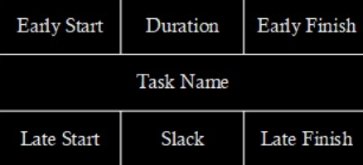

Steps to Calculate Activity Diagram:
  - First make basic diagram with just their name and Duration.
  - Calculate forward pass like
Early Finish = Early Start + Diagram
  - From Two diagram to One diagram for Forward Pass always consider big number.
  - Final Early Finish is Equal to Final Late Finish
  - Then calculate Backward Pass like
Late Start = Late Finish – Duration
  - From Two Diagram to One diagram for Backward Pass always consider small number.
  - Calculate Slack = Early Finish – Late Finish

Critical Path Identification (Page 202)
- Definition: The sequence of activities that represents the longest path through the project.
- Impact: Any delay in a critical path activity will delay the entire project.
- Zero Slack: Activities on the critical path have a slack of zero.

Gantt Charts (Page 207)
Gantt charts are bar charts used to display the project schedule, showing start and finish dates of activities and their logical relationships. In software like Microsoft Project, red bars typically represent critical tasks while blue bars represent non-critical tasks.

Chapter 8: Resource Management

Resource Types
Resources are classified into three primary categories required for the efficient deployment of project activities:
- Human Resources (HRs): Includes the core project team members and other personnel required for specific project activities.
- Physical Resources: Encompasses equipment, materials (raw materials, supplies, consumables), inventory, facilities, infrastructure, and IT assets such as hardware, software, and cloud computing resources.
- Services: Includes external support from contractors, subcontractors, and consultants.

Project Resource Management Plan
This sub-plan of the overall project plan provides guidelines for estimating, acquiring, managing, and utilizing physical and team resources. Its key components include:
- Project Organization Charts: Visualizes reporting relationships and may include a team charter to establish shared values and operating guidelines.
- Resource Requirements: Details the types of resources, required skills, roles, responsibilities, and the total effort in hours linked to WBS activities.
- Resourcing Strategy: Defines how resources are acquired and eventually released from the project.
- Control and Safety: Outlines methods for monitoring resources and specific health and safety practices to be followed.
- Rewards and Recognition: Criteria for rewarding team members based on their performance.

Resource Breakdown Structure (RBS)
The RBS is a hierarchical structure that illustrates the project's resource needs by category. For example, an M-Commerce project RBS might branch into Human Resources (analysts, designers, developers), Hardware (laptops, mobile devices), Software (SDKs, cloud tools), and Materials.

Estimating Resources
The goal is to assign appropriate resources to every activity in the activity list using several techniques:
- Expert Judgment: Consulting subject matter experts with technical knowledge in the relevant domain.
- Alternative Analysis: Evaluating different options for assigning resources, such as varying the number or kind of resources used.
- Analogous Estimating: Using information and lessons learned from similar past projects to estimate current needs.
- Bottom-Up Estimating: Decomposing activities via the WBS to estimate individual resource needs and then aggregating them for a total estimate.

Resource Allocation and Leveling
- Resource Loading: The process of assigning specific resources to project activities.
- Resource Usage Calendar: A tool that displays the amounts of resources assigned to tasks over the project's timeline.
- Resource Leveling: A technique used to address resource overallocation. It examines the unbalanced use of resources and resolves conflicts by rescheduling tasks, often sequentially rather than simultaneously, which can lead to a risk of schedule delay.

Schedule Compression Techniques
These techniques are used to shorten the project duration without reducing the project scope:
- Crashing: Adding more resources to critical activities to save time, which typically increases project costs (e.g., approving overtime or hiring additional staff).
- Fast-Tracking: Performing activities in parallel that were originally planned to be done in sequence. This requires increased coordination to prevent quality risks but does not necessarily increase costs as much as crashing.

Chapter 9: Project Cost and Procurement Management

One criterion for project success is completing the work within budget.

Some of the reasons why projects fail to keep themselves on track with regard to their budget can be outlined below:
1. Project activities may not be aligned with project objectives and scope.
Example: Missing travel and testing expenses for an off-site factory inspection.
2. Activity durations may be estimated incorrectly.
Example: Estimating 1 week for a task that actually needs 2 weeks increases labor cost.
3. Cost per resource may be underestimated.
Example: Assuming $20/hour for an analyst instead of $30/hour causes budget overrun.
4. Risks may not be identified properly during planning.
Example: Ignoring a major technical risk leads to unexpected extra costs later.

Project Cost Types
Costs are categorized based on their relationship to specific tasks:
- Direct Costs: Directly related to specific tasks, such as the labor hours of a developer or raw materials.
- Project-Induced Overhead Costs: Costs caused by the project's existence but not tied to one task, such as the project manager’s salary, office rental for the team, or general supplies.
- General Administrative Costs: Indirect expenses incurred even without the project, such as HR or accounting department support.

Cost Management Plan: Process Descriptions
The cost management plan provides guidelines for estimating, budgeting, and controlling costs. It includes:
- Units of Measurement: Defined shifts, daily hours, and measurement systems (metric or imperial).
- Level of Accuracy: The acceptable range for realistic estimates (e.g., ±10%) and procedures for currency fluctuations.
- Level of Precision: The degree to which estimates are rounded (e.g., rounding $995.75 to $1,000).

Cost Estimation Methods
The book details five primary techniques for determining monetary resources:
- Expert Judgment: Consulting experts in finance, procurement, or specific technical fields.
- Analogous Estimating: Using the actual cost of previous similar projects as a basis for the current one.
- Parametric Estimating: Using mathematical models, such as multiplying the square footage of a building by a standard cost-per-unit.
- Three-Point Estimating: Using Optimistic, Most Likely, and Pessimistic scenarios to calculate an expected cost (often using a Beta distribution).
- Bottom-Up Estimating: Aggregating the costs of individual work packages from the WBS to find the total project cost.

Establishing the Budget and Components
Determining the budget involves aggregating estimated costs to establish an authorized cost baseline.
- Contingency Reserves: Funds set aside for "known-unknowns" (identified risks).
- Management Reserves: Funds for "unknown-unknowns" (unforeseen risks like a pandemic) that are not part of the cost baseline.
- Budget Components: The total project budget consists of the Cost Baseline (work package estimates + contingency reserves) plus the Management Reserve.

Project Procurement Management
Procurement involves documenting decisions, specifying the approach, and identifying sellers.
- The Procurement Cycle: Includes identifying needs, preparing RFPs (Request for Proposals), evaluating vendors, awarding contracts, and closing them out.
- Make or Buy Analysis: Determining whether it is more cost-effective to develop a solution internally or purchase one from an external vendor.
- Contract Types:
  - Fixed-Price: The buyer pays a constant price regardless of the vendor's effort.
  - Cost Reimbursable (Cost Plus): The buyer pays for the actual cost of work plus a fee.
  - Time and Materials: The buyer pays a set rate for time spent and for all materials used.

Establishing the Project Budget
Project budget is created by adding up all estimated costs of activities and work packages. This total becomes the approved cost baseline used to monitor project spending.

Cost Aggregation
Costs of individual activities are added together to form the total project budget.
Example: UI cost + backend cost + testing cost = total app development budget.
Time-Phased Budget
Budget is distributed over time based on the project schedule.
Example: $50,000 total cost split across 5 months of development work.

Cost Baseline
Approved budget including contingency reserves used for tracking performance.
Example: $10,000 + $2,000 reserve = $12,000 baseline for a task.

Contingency Reserve
Extra budget for known risks (“known-unknowns”) within specific activities.
Example: Additional $2,000 added for possible developer shortage risk.

Management Reserve
Extra budget for unexpected risks (“unknown-unknowns”) affecting the whole project.
Example: Extra fund kept for events like COVID-19 impacting project cost.

Reserve Analysis (Project Budget)
Reserve analysis is the process of adding extra money to the project budget to handle risks and uncertainties.

Contingency Reserve (Known-Unknowns)
Extra budget for risks that are identified during planning and can be predicted.
Example: Adding extra cost for possible shortage of software developers in the development phase.

Example (M-Commerce Project):
Risk of developer shortage increases cost in “Analysis/App Requirements” and “Development” phases.

Management Reserve (Unknown-Unknowns)
Extra budget for completely unexpected risks that cannot be planned in advance.
Example: Sudden impact of COVID-19 affecting all project activities and increasing overall costs.
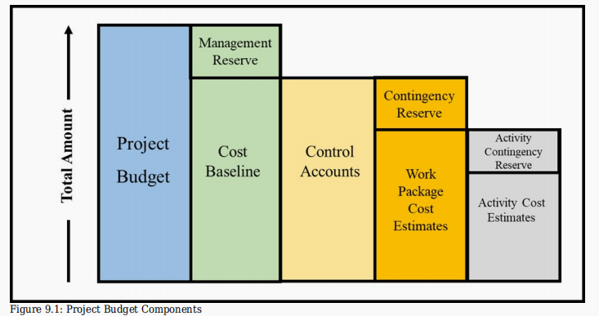

Project Procurement Management
The “procurement cycle” reflects all procurement-related activities from when the decision is made to outsource equipment through to the payment of bills and closing of procurement contracts.
In less complex projects, the project team performs the work associated with procurement management.

The procurement cycle includes: (In Less Complex Project)
- Identifying the required materials, equipment, and supplies
- Identifying the potential vendors
- Preparing requests for quotes (RFQs) and requests for proposals
- Evaluating RFQs and RFPs to select the most suitable vendors
- Awarding and signing contracts
- Administering the contract and monitoring vendors’ performance
- Managing contract changes
- Closing out the contract upon work completion
The procurement management plan details how the procurement process will be managed.
It can include the following information:
- Roles and responsibilities of the project team and procurement professionals
- The types of contracts we plan to use, and any metrics that will be used to measure the contractor’s performance.
- The planned delivery dates for the work or products we are contracting.
- The organization’s standard procurement documents and processes that our project must use and comply with.
- How many vendors or contractors are involved and how they will be managed.
- How purchasing may impact the constraints and assumptions of the project plan.
- Coordination of purchasing lead times with the development of the project schedule.
- Identification of prequalified sellers (if known).

Contract Types
We should know a little bit about the major kinds of contracts so that we choose the one that creates the fairest and most workable deal for us and the contractor.
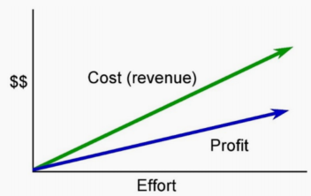
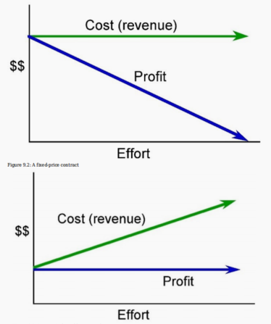

A project resource plan shows what resources (people, tools, money) you need, when you need them, and how they will be used.

Here is a simple way to create one:
1. Identify tasks
Break the project into small tasks (use WBS – Work Breakdown Structure).

2. List required resources
For each task, decide what you need:
- People (developers, designers, etc.)
- Tools/technology
- Materials or budget

3. Assign resources
Match the right person or resource to each task based on skills.

4. Estimate time and effort
Decide how long each task will take and how much work is needed.

5. Create a schedule
Plan when each resource will be used (timeline or Gantt chart).

6. Check availability
Make sure resources are available when needed and avoid overloading.

7. Monitor and update
Track usage during the project and adjust if needed.
Simple idea:
Resource plan = who + what + when + how much for your project.

Chapter 10: Project Risk

Risk Definitions and Types
A project risk is defined as an uncertain event or condition that, if it occurs, has a positive or negative effect on one or more project objectives.
- Negative Risks (Threats): Uncertainties that can jeopardize project progress, such as machine failure, late vendor deliveries, or a key team member leaving the organization.
- Positive Risks (Opportunities): Uncertainties that, if they occur, make it easier to achieve objectives. Examples include finding a more efficient way to perform a task or acquiring materials at a lower price than estimated.
- Known-Unknowns: Identifiable risks in the planning stage. These are addressed using contingency reserves.
- Unknown-Unknowns: Unpredictable risks (like a pandemic). these are addressed using management reserves.
- Individual vs. Overall Project Risks: Individual risks affect specific activities or objectives, while overall risks impact the project as a whole, such as a major funding shortfall.

Risk Management Plan
This plan describes how risk management activities will be structured and performed. Key components include:
- Methodology: Tools and data sources used for risk identification and assessment.
- Risk Breakdown Structure (RBS): A hierarchical tool used to facilitate risk identification by grouping risks into categories like Technical, Management, Commercial, and External.
- Roles and Responsibilities: Defining which team members will own and monitor specific risks.

Identifying Risks and the Risk Register
Risks are identified using checklists, team experience, and industry expert judgment. All identified risks are recorded in the Risk Register, a living document that includes:
- Risk ID and Description.
- Risk Owner: The person responsible for monitoring the risk.
- Risk Trigger: Cues that indicate a risk is becoming an issue.
- Probability and Impact Scores.
- Response Strategies.

Qualitative Risk Assessment
This involves prioritizing risks by assessing their probability of occurrence and their impact if they happen.
- Scale: Project teams often use a five-point scale (Very Low to Very High) for both probability and impact.
- Impact Areas: Impacts are assessed across different dimensions, such as Schedule (e.g., a "Very High" impact might mean a delay of >50%) and Cost (e.g., a "Very High" impact might mean a budget overrun of >50%).
- Severity Score: Calculated by multiplying the probability value by the impact value. Severity is typically categorized by color: Green (Low), Orange (Medium), and Red (High).

Risk Response Strategies
Once prioritized, the team develops strategies to handle the risks.
For Negative Risks (Threats):
- Escalation: Moving the risk to a higher authority (e.g., project sponsor) if it's outside the project manager's control.
- Avoidance: Changing the project plan to eliminate the threat (e.g., using a proven technology instead of a new, experimental one).
- Transfer: Shifting ownership/impact to a third party (e.g., purchasing insurance).
- Mitigation: Taking action to reduce the probability or impact of the risk (e.g., building a prototype or assigning highly skilled staff).
- Acceptance: Doing nothing because the risk is low-priority or the cost of action is too high.
For Positive Risks (Opportunities):
- Escalation: Notifying senior management of a potential business-wide value stream.
- Exploitation: Ensuring the opportunity happens (e.g., using new technology to finish early).
- Sharing: Partnering with another company to share the gains.
- Enhancing: Increasing the probability or impact of the opportunity.
- Acceptance: Taking no proactive action.

Contingency Plans
A contingency plan is an alternative method for accomplishing a goal when a specific risk event occurs. These are funded by contingency reserves (part of the cost baseline) to address "known-unknowns"

Chapter 11: Monitoring and Controlling

Monitoring vs. Controlling (Pages 299–300)
While often grouped together, these two concepts have distinct functions:
- Monitoring: The process of collecting project performance data, producing performance measures, and reporting/disseminating that information.
- Controlling: The active process of comparing actual performance against planned performance (the baseline), analyzing variances, evaluating alternatives, and recommending corrective actions to get the project back on track.

Monitoring and Control System Requirements
A project requires a structured system to ensure it meets objectives, considering the following:
- Data Collection: Determining what information is needed, who collects it, and the frequency of collection.
- Reporting: Determining who prepares reports and which stakeholders receive them based on their power and interest levels.
- Timing: Monitoring begins at project initiation and increases in intensity during the planning and execution phases to prevent the project from getting off track

Chapter 12: Agile (Adaptive) Project Management

Foundations: Introduction to Agile and the Agile Manifesto
- Historical Context: Agile emerged in the 1980s and 90s as software development teams struggled with the linear, sequential nature of the waterfall approach. It was heavily influenced by Lean manufacturing (Toyota), just-in-time processes, and Total Quality Management (TQM).
- The Agile Manifesto (2001): A group of 17 software leaders created a set of core values that prioritize:
  - Individuals and interactions over processes and tools.
  - Working software over comprehensive documentation.
  - Customer collaboration over contract negotiation.
  - Responding to change over following a plan.

Agile Manifesto
The Agile Manifesto is a set of values and principles created in 2001 that defines the Agile approach to software development, focusing on flexibility, collaboration, and customer satisfaction.

The 12 Agile Principles

1. Our highest priority is to satisfy the customer through early and continuous delivery of valuable software.
2. Welcome changing requirements, even late in development. Agile processes harness change for the customer’s competitive advantage.
3. Deliver working software frequently, from a couple of weeks to a couple of months, with a preference for the shorter timescale.
4. Business people and developers must work together daily throughout the project.
5. Build projects around motivated individuals. Give them the environment and support they need, and trust them to get the job done.
6. The most efficient and effective method of conveying information to and within a development team is face-to-face conversation.
7. Working software is the primary measure of progress.
8. Agile processes promote sustainable development. The sponsors, developers and users should be able to maintain a constant pace indefinitely.
9. Continuous attention to technical excellence and good design enhances agility.
10. Simplicity – the art of maximizing the amount of work not done – is essential.
11. The best architectures, requirements and designs, emerge from self-organizing teams.
12. At regular intervals, the team reflects on how to become more effective, then tunes and adjusts its behavior accordingly

Agile vs. Waterfall
- Waterfall (Predictive): A linear process where one stage must be finished before the next begins. It works best when requirements are very well understood, the duration is short, and uncertainty is low.
- Agile (Adaptive): Compresses sequential phases into small "timeboxes" or iterations. It is better suited for projects with high uncertainty where the product scope cannot be easily defined upfront.
- Hybrid Approach: Many real-life projects use a blend of both, keeping sequential phases while adding frequent stakeholder feedback loops.

Outcomes: Benefits and Challenges
- Benefits: Early delivery of business benefits, increased adaptability to changing customer needs, improved quality through constant feedback, and higher stakeholder satisfaction.
- Challenges: Difficulty in changing the organizational mindset, lack of process visibility for managers, potential for "scope creep," and the need for significant leadership participation.

Frameworks and Methods
- Scrum: The most popular agile method (used by 66% of organizations). It uses specific roles (Product Owner, Scrum Master, Development Team), events (Sprints, Daily Standups), and artifacts (Product Backlog, Increments).
- Kanban: A visual system for managing work as it moves through a process. It uses a "Kanban board" and focuses on limiting Work in Progress (WIP) to optimize flow.
- Scrumban: A hybrid approach originally designed to transition from Scrum to Kanban, utilizing the structure of Scrum with the process improvement of Kanban.
- Extreme Programming (XP): Focused on engineering practices like pair programming and writing unit tests before writing code.
- SAFe (Scaled Agile Framework): The most common scaling framework used to apply agile patterns across large enterprise levels.

Common Agile Practices
- User Stories: Requirements written from the perspective of the end user: "As a [user], I want to [action] so that I can [benefit]".
- Daily Standups: Short morning meetings where the team discusses what they completed, what they plan to do next, and any impediments (risks) they face.
- Retrospectives: Meetings at the end of each cycle to discuss what went well and what could be improved, fostering a culture of continuous learning.

Use the adaptive model (Agile) instead of the waterfall model when:
- Requirements are unclear or likely to change
- The project needs frequent updates and feedback
- You want to deliver work in small parts (iterations)
- The environment is dynamic or uncertain
- Close customer involvement is needed
Simple idea:
Adaptive = flexible and change-friendly
Waterfall = fixed and step-by-step (good when everything is clearly defined)

